1. Unit 1 Foundations of American Democracy
2. Fundamental Principles of Democracy.
3. Direct Democracy – citizens meet and vote directly on government decisions.
4. Representative Democracy (Republic) – citizens choose officials who make decisions on government policy.
5. Magna Carta (1215) – the first ever attempt to limit the power of the British King, guaranteed all people certain rights
6. Enlightenment Philosophers –Locke and Rousseau
7. Social Contract Theory – principle that people enter into a social contract with the government and allow to be ruled
8. Consent of the Governed – principle that there are no supreme rulers, all rulers depend on the approval of the people, when governments fail to protect rights the people have the right to change the government
9. Natural Rights – principle that all people are born with certain rights: life, liberty, and property (Jefferson changes property into pursuit of happiness.
10. Declaration of Independence – Thomas Jefferson’s document built on principles of “life, liberty, and the pursuit of happiness” consent of the governed, and social contract theory. It also justified American revolution against England
11. Common Good – Belief in doing what’s best for the nation overall.
12. Popular Sovereignty – Belief that the ultimate authority rests with the people
13. Majority Rule – Belief that government is run based on the will of the majority.
14. The First Government – Articles of Confederation
15. Weak association of states (states very independent)
16. No central executive power
17. No federal power to tax citizens directly
18. Federal government could raise an army, (but not pay for it), print money, declare war, and run the post office
19. 9 out of 13 states were required to vote to pass a law
20. With no strong central government supervision, states could get away with taxing and printing money, and making foreign treaties,
21. Shays’ Rebellion – Farmer rebellion in Massachusetts 1786-1787 protesting mortgage foreclosures and terrible economy. Rebellion represented how weak the central government was, and terrified many Americans
22. Constitutional Debate
23. Constitutional Convention meets in Philadelphia, 1787 to write new constitution
24. All delegates supported Representative Democracy (Republic) – democracy where people elect representatives who pass laws
25. Supported three branches – executive, legislative, and judicial
26. Serious debate between Federalists vs. Anti-Federalists, North vs. South, Big States vs. Small States over new government
27. North-South Compromises – 3/5 Compromise counted slaves as 3/5 of a person to give the south more representatives
28. Connecticut Compromise – (Bicameralism) – Established two equal bodies (House of Representatives and Senate) one based on population, one giving all states equal representation. This was a compromise between big states (Virginia Plan) and small states (New Jersey Plan) over the format of the Congress.
29. Federalists (Hamilton, Madison) supported the Constitution because it gave power to a strong central government. Anti-federalists opposed the constitution because they thought the national government would become tyrannical and take power away from the states.
30. Federalist Papers – articles written by Madison, Hamilton, and Jay arguing for the constitution.
31. Federalist Paper #10 – written by Madison, discusses importance of factions, factions are inevitable, but factions are best handled by a large republic.
32. 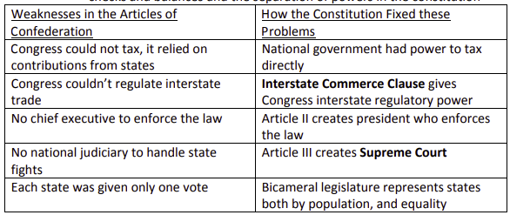Federalist Paper #51 – written by Madison, discusses importance of checks and balances and the separation of powers in the constitution
33. The Constitution
34. Article I –Legislative Branch
35. Article II –Executive Branch
36. Article III –Judicial Branch
37. Article IV – Interstate relations
38. Article V – Amendment process
39. Separation of Powers – Each of the three branches has its own power and independence
40. Legislative Branch – Passes laws
41. Executive Branch – Executes laws
42. Judicial Branch – Interprets laws (this power comes from Supreme Court Case Marbury vs. Madison – set dogma of judicial review, where the Supreme Court may rule an act of the President or Congress unconstitutional)
43. 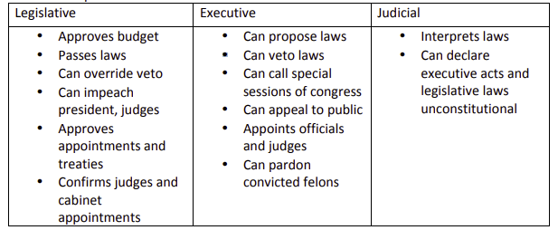Checks and Balances – Each branch has some power over the others, but retains independence.
44. Federalism – Separation between powers of the Federal, State, and Local governments
45. Confederacy – System of government in which the central government is very weak, and most of the true power lies in individual states
46. Unitary System – System of government in which the central government is extremely powerful, and individual states have few powers
47. Dual Federalism, aka “Layer Cake” Federalism (1789-1932) – Belief that the state and national governments are supreme within their own sphere of influence
48. Cooperative Federalism, aka “Marble Cake” Federalism – sharing powers between state and federal governments
49. Fiscal Federalism – government’s patterns of spending, taxing, and providing grants to influence state and local governments
50. Grants-in-aid – money given from the federal government to the states
51. Categorical grants – federal grants for specific purposes (building an airport)
52. Block grants – broad grants from the federal government that give local/state governments a lot of freedom to spend money as they please without many strings attached. The Welfare Reform Act of 1996 began transferring more authority back to the states through block grants
53. Revenue sharing – federal sharing of a fixed percentage of its revenue with the states
54. Mandates – terms set by the federal government that states must meet if they accept federal grants.
55. Devolution – process of returning power to the states, this began during New Federalism under presidents Nixon, Reagan, and Bush
56. Federal Powers – Express, Implied, and Inherent powers:
57. Express powers – powers listed (enumerated) in the constitution for the Federal government: go to war, raise an army, regulate interstate and foreign commerce, establish post offices
58. Implied powers – Based on necessary and proper clause (elastic clause) – gives congress flexibility to make laws necessary and proper for carrying out express powers, upheld in McCulloch v. Maryland
59. 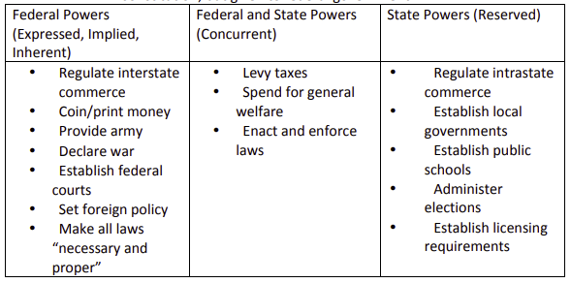Inherent powers – powers dealing with foreign policy not in constitution, but given to federal government
60. Denied Powers – Powers explicitly denied to government:
61. suspending writ of habeas corpus (being imprisoned without formal accusation)
62. passing bills of attainder: laws that declare a person to be guilty
63. ex post facto laws: “after the fact,” laws that make an act illegal after it was performed
64. Concurrent Powers (shared by Federal and State governments) – power to tax and spend, establish courts, make laws
65. Reserved to States (10th amendment) – any power not denied nor given to federal government is reserved for state governments (create local governments).
66. Supremacy Clause – Federal law is superior to state law. This came out of the court case McCulloch vs. Maryland, in which there was debate as to whether or not the Bank of the United States had to pay Maryland state taxes. The Supreme Court ruled that because the Bank of the US was NATIONAL it did not have to follow Maryland STATE law. This ruling overturned the idea of nullification by which states could override federal law.
67. Interstate Commerce Clause – Gives Federal Government authority to regulate all of interstate commerce. This clause gives the federal government authority 5 to regulate businesses that go between state lines, and justifies many federal laws (Civil Rights Act)
68. Take Care Clause – president must enforce ALL laws passed by congress
69. Full Faith and Credit – states must honor laws and court rulings of other states
70. Privileges and Immunities – requires states to extend same privileges and immunities to all citizens (even of other states)
71. Bill of Rights – First 10 amendments to the Constitution that guarantees individual and states’ rights. This was a concession the federalists made to the anti-federalists to ensure constitution would be ratified
72. Amendment 1 – freedom of speech, assembly, petition, religion, press
73. Amendment 2 – right to bear arms
74. Amendment 4 – no unreasonable searches and seizures
75. Amendment 5 – right to a trial, no double jeopardy, individuals are not required to testify against themselves
76. Amendment 6 – right to a speedy, public, and impartial trial with lawyer
77. Amendment 8 – no excessive bails or fines, no cruel and unusual policies
78. Amendment 10 – powers not given to the federal government or denied of the states are reserved to the states (states’ rights)
79. How to Amend the Constitution
80. 2/3 of congress propose amendmentà3/4 of states ratify it
81. State convention called by 2/3 of states propose amendmentsà3/4 of states ratify (this method has only been used once, 21st amendment)
82. **Unit 2 Interactions Among Branches of Government**
83. Changes to System of Checks and Balances
84. Referendum – people vote on whether or not to accept a law passed by state legislature, or a proposed amendment to the state constitution
85. Initiative – people vote on laws and constitutional amendments within state (direct democracy)
86. Recall – voters remove elected officials.
87. **Unit 3 Civil Liberties and Civil Rights**
88. **Unit 4 American Political Ideologies and Beliefs**
89. Political Culture, Beliefs, and Behaviors
90. Alexis de Tocqueville – Frenchmen who visited America in the 1800's and described the young democracy he saw
91. Political Culture – a coherent way of thinking about how politics and the government ought to be carried out
92. Americans tend to support free enterprise with some limits
93. Americans tend to be committed to individual responsibility and economic individualism
94. Americans believe strongly in equality of opportunity, NOT result
95. Americans tend to be particularly patriotic and aware of their rights
96. Religion tends to play a very influential role in determining an individual’s political views
97. Political Socialization – manner in which people develop their political views (family, friends, media, current government, education)
98. Ideologies (People may be liberals/conservatives either economically or socially.)
99. Liberal – large federal government involvement needed to provide for the people (welfare, new deal, great society)
100. Socialist – belief in an extremely powerful state to protect people
101. Conservative – belief that limited government is necessary to grow strong economy, very pro-business anti-regulation
102. Libertarianism – belief in very small government and extreme focus on individual and business rights, no regulation of industry
103. Demographics trends – changes in the way people of a certain socio-economic background vote (politicians follow these very closely)
104. Who votes? Whites vote more than blacks. Rich vote more than poor. Women vote more than men. Old vote more than young. Educated vote more than uneducated.
105. Women, blacks, Hispanics, young people, blue collar workers vote liberal. Men, wealthy whites, religious people, rural people vote conservative.
106. The Census – Every 10 years a count of the total population, different ethnic groups, religions, and how people vote
107. Reapportionment – state legislatures reapportion (resize) state congressional districts after every census
108. Gerrymandering – The practice of redistricting in order to benefit a specific party by drawing districts based on the demo of their residents (Baker v. Carr and Shaw v. Reno were court cases in which the supreme court ruled that gerrymandering was unconstitutional)
109. Redistricting – after every census the congressional districts are redrawn based on population
110. Voting Behavior – Since 1960 voting turnout has greatly decreased because of the very difficult process of voter registration. People vote because of the party of the candidate, on basis of candidate, and on basis of issues
111. Party Identification – when people identify with a political party based on issues
112. Political Efficacy – belief that you can participate in politics, or that government will respond (my vote counts)
113. Civic Duty – belief that one has an obligation to participate in civic and political affairs
114. Political Parties
115. Linkage Organizations – organizations that link the people with government
116. Congressional elections use winner-take-all systems in which the winner of a plurality wins (single-member district)-> Because of the winner-take-all system, we have a two party system
117. Third parties – represent specific ideological positions, sometimes can serve as “spoilers” but rarely make much of an impact
118. Parties help organize the government, organize election process, fundraise, hold national convention and form party platform, educate voters, and get out the vote
119. Before primary system, party leaders actually chose the candidates
120. Parties are expected to be “loyal opposition” when other party is in power
121. Typically we have Divided Government – one party controls white house, other controls congress
122. Parties have a national leadership, but local chapters have a lot of power
123. Realignment – major change in the core members/beliefs of a political party either one major party is replaced by another, or the two major parties completely change viewpoints
124. Dealignment – when people abandon parties and become independents
125. Party activists promote certain policies, candidates, and ideologies
126. **Unit 5 Political Participation**
127. Types of Elections
128. General elections – held every four years in which president is elected
129. Primary elections – a political party’s elections to determine nominee for general election
130. Open primaries – people from either party can vote (must choose to vote for either democrats or republicans)
131. Closed primaries – people can only vote if they are a registered member of the party
132. Caucuses – candidate nomination process in which party members meet to discuss and decide on candidate
133. Elections